

Dealing with medical conditions in children – preschool procedure table

National Quality Standard Education and Care Services National Law and National Regulations | Associated department policy, procedure or guideline | Reference document(s) and/or advice from a recognised authority
NQS: 2.1, 2.2  Regulations: 90, 91, 92, 93, 94,  95 | Leading and operating department preschool guidelines  Student health in NSW schools: A summary and consolidation of policy  First aid procedures [PDF 274 KB]  Anaphylaxis and allergy procedures for schools [PDF 250 KB]  Asthma | Australasian Society of Clinical Immunology and Allergy (ASCIA)  ASCIA Risk management strategies for schools, preschools and childcare services [PDF 1,161 KB]  National Asthma Council Australia  Epilepsy Australia Diabetes Australia  Best Practice Guidelines CEC – Allergy Aware  ACECQA’s policy and procedures guidelines – Dealing with medical conditions in children

Responsibilities

School principal | The principal as Nominated Supervisor, Educational Leader and Responsible Person holds primary responsibility for the preschool.  The principal is responsible for ensuring:  - the preschool is compliant with legislative standards related to this procedure at all times  - all staff involved in the preschool are familiar with and implement this procedure  - all procedures are current and reviewed as part of a continuous cycle of self- assessment.  These tasks may be delegated to other members of the preschool team, but the responsibility sits with the principal.
Preschool supervisor | The preschool supervisor supports the principal in their role and is responsible for leading the review of this procedure through a process of self-assessment and critical reflection which includes:  - analysing complaints, incidents or issues and what the implications are for the updates to this procedure  - reflecting on how this procedure is informed by relevant recognised authorities  - planning and discussing ways to engage with families and communities, including how changes are communicated  - developing strategies to induct all staff when procedures are updated to ensure practice is embedded.
Preschool teacher(s) and educator(s) | Preschool teachers and educators are responsible for working with the preschool leadership team to ensure:  - all staff in the preschool and daily practices comply with this procedure  - this procedure is stored in a way that it is accessible to all staff, families, visitors and volunteers  - they are actively involved in the review of this procedure, as required, or at least annually  - details of this procedure’s review are documented.

Procedure
Individual health care plans | The preschool enrolment form requires the parent to document relevant medical information.  - An individual health care plan will be developed for any child with a medical condition diagnosed by a registered medical practitioner. This may include, but is not exclusive to:  - a child diagnosed with asthma, diabetes, epilepsy or a food or insect allergy  - a child at risk of anaphylaxis  - a child who requires the administration of health care procedures.  - Upon acceptance of the enrolment by the principal the preschool teacher organizes a meeting with the school Learning and Support Teacher (LAST) and parent/carer where:  - all extra relevant health information is collected and included in the Individual Health Care Plan Cover Sheet  - the parent/carer provides the emergency medical management or action plan,  - a risk management plan is developed and,  - a communication plan is created.  - The LAST will collate the necessary information and prepare the relevant plans.  - In addition, the following documentation will be developed and collated as an attachment to the health care plan:  - The family must provide an emergency medical management or action plan for their child. This must be developed, dated and signed or stamped by a medical practitioner. In the event of an emergency, teachers and educators will implement this plan.  - A risk assessment plan must be developed for the child in consultation with their parent. This should include information related to potential triggers for the child and how risks will be minimised in the preschool environment. The parent’s signature must be included on the plan as verification that they were consulted. Teachers and educators will implement this plan.  - A communication plan must be developed to document:  - how all staff and volunteers will be made aware of the child’s needs  - that all staff are able to identify the child  - that all staff are able to locate the child’s management plan and medication  - the parent’s preferred method of communication to inform the preschool of any changes in the child’s management, medication, or the risks identified on their risk minimisation plan  - record any communication between the family and preschool around the child’s condition.  - The parent will be given a copy of this procedure and the Student Health in NSW Public Schools: A summary and consolidation of policy.  - Prescribed medication must be supplied for children with a medical condition before commencement and whenever the child is in attendance

Asthma | - Asthma is a medical condition that affects the airways. From time to time, people with asthma find it harder to breathe in and out, because the airways in their lungs become narrower.  - In developing the risk assessment plan for children with asthma, triggers that will be considered are smoke, colds and flu, exercise and allergens in the air. The plan will note how the child’s relevant triggers will be minimised in the preschool environment.  - The most common symptoms of asthma are:  - wheezing – a high-pitched sound coming from the chest while breathing  - a feeling of not being able to get enough air or being short of breath  - a feeling of tightness in the chest  - coughing.  - If a child known to suffer asthma has a flare – up, their emergency action plan will be applied and an ambulance called.  - If a child not known to have asthma has a flare – up, the preschool’s general use reliever medication will be administered (parent authorisation is not required), following the emergency action plan and an ambulance called.
Diabetes | - Diabetes is a serious complex condition which can affect the entire body, requiring daily self-care. When someone has diabetes, their body can’t maintain healthy levels of glucose in the blood.  - The signs and symptoms of low blood sugar include the child presenting pale, hungry, sweating, weak, confused and/or aggressive.  - The signs and symptoms of high blood sugar include thirst, need to urinate, hot dry skin, smell of acetone on breath.  - How a child’s diabetes will be managed and supported at preschool will depend on the type of diabetes they have. An extensive health care plan, including an emergency action plan, will be in place before they commence preschool.

Epilepsy | - Epilepsy is a disorder of brain function that takes the form of recurring convulsive or non-convulsive seizures.  - Seizures can be subtle, causing momentary lapses of consciousness, or more obvious, causing sudden loss of body control.  - If a child known to suffer epilepsy has a seizure, apply their individual emergency management plan.  - If a child is not known to suffer epilepsy suffers a seizure, follow the instructions on the Epilepsy Australia seizure first aid poster [PDF 369 KB]
Anaphylaxis | - Anaphylaxis is a severe, life-threatening allergic reaction and is a medical emergency. If a child is suspected to be suffering from anaphylaxis, an ambulance will be called immediately.  - Anaphylaxis occurs after exposure to an allergen (usually to foods, insects  - or medicines), to which a person is allergic. Not all people with allergies are at risk of anaphylaxis.  - Signs of mild or moderate allergic reaction are swelling of the lips, face, eyes, a tingling mouth, hives or welts, abdominal pain or vomiting.  - Signs of a severe allergic reaction (anaphylaxis) are difficult/noisy breathing, swelling of tongue, swelling/tightness in throat, wheeze or persistent cough, difficulty talking and/or hoarse voice, persistent dizziness or collapse, pale and floppy.  - If a preschool child known to be at risk of anaphylaxis suffers anaphylaxis, their emergency action plan will be applied and their emergency medication administered.  - If a child not known to be at risk of anaphylaxis, is suffering anaphylaxis, the preschool’s general-use EpiPen Junior will be administered, following the instructions on the ASCIA First Aid Plan for Anaphylaxis EpiPen 2023 [PDF 252 KB]. Parent authorisation is not required for this to be administered.

Administration of medication | - Before administering medication to a child, a staff member will have completed the department’s Administration of Medication in Schools e-Safety e-Learning course.  - On arrival at preschool, the parent or carer hands the child’s medication to a staff member for safe storage.  - All non-emergency medication is stored in a locked cupboard, or locked container in the refrigerator, out of reach of children.  - If medication has a pharmacy label, it must show the child’s name and the medication must be administered in accordance with the instructions on it.  - If medication does not have an attached pharmacy label, the medication must be administered in accordance with any written instructions provided by a registered medical practitioner.  - The parent completes the first section of the medication record, documenting dosage and administration details and authorising the medication to be administered to their child.  - The staff member places the medication form in the medication reminder display and completes the front facing medication reminder sheet.  - When a staff member administers medication to a child, they record the details on the medication record, with another member of staff witnessing that the medication was administered as prescribed. This is to be made available to the family for verification when they collect their child.  - A child's medication record is stored in the labelled Health Care Plans folder.  - Finalised medication forms are to be stored with the child’s enrolment file.  - The expiry dates of children’s individual medication kept in the preschool will be monitored regularly and families asked to replace them before they expire. This communication will be recorded in the communication plan.  - The staff member administering the medication will check the stored medication is in date before administering it to the child. If the medication is due to be replaced or disposed of the staff member will inform the preschool administration officer to inform the parents/carers.  - In addition to above the preschool administration officer will check the expiration date of all stored medications at the start of each term and inform parents/carers if medication requires replacement. The date of this communication will be recorded in teams/preschool/ 2024/ADMIN/STUDENT INFORMATION by the preschool School Administration Officer.

Emergency medication | - Emergency medications (EpiPen Jnr. and Ventolin reliever) are stored in a location that is easily accessible to staff, but inaccessible to children.  - These are stored in the First Aid kit (red) in the left hand side cupboard immediately to the left of the mainroom entrance door.  - Individual emergency medication is stored with a copy of the child’s emergency management or action plan in small basket beside the first aid kit (red).  - In an anaphylaxis or asthma emergency situation, a staff member will administer emergency medication (EpiPen Jr or Ventolin reliever) to a child who requires it. Parent authorisation is not required for this.  - If emergency medication is administered:  - an ambulance will be called  - the principal will be notified  - the child’s parent or carer will be notified  - a notification will be made to Early Learning (phone 1300 083 698) within 24 hours.
Student Health in NSW Public Schools: A Summary and Consolidation of Policy - Link | Parent and family information to support student with identified healthcare needs.  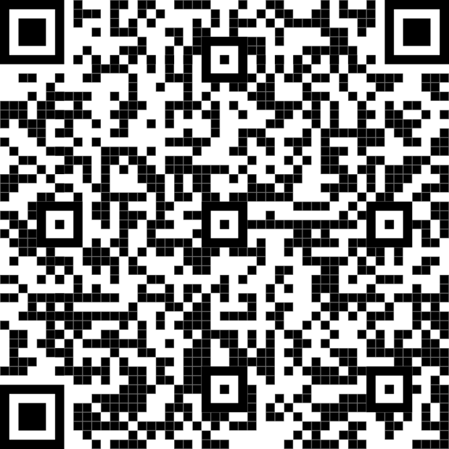

Record of procedure’s review
Date of review | 10/10/2024
Who was involved | Alison Finlayson
Key changes made and reason why | Nil changes
Record of communication of significant changes to relevant stakeholders | Principal: Alison Finlayson  Staff: Nil changes  Parents: Nil changes required for this procedure.  Please note, parents must be notified at least 14 days prior to a change that may have a significant impact on their service’s provision of education and care or a family’s ability to use the service.

Date of review | 10/06/2024
Who was involved | Alison Finlayson
Key changes made and reason why | Nil changes - updated template available from Early Learning
Record of communication of significant changes to relevant stakeholders | Principal: Alison Finlayson  Staff: New templates from Early Learning to be implemented during review cycle and minuted in staff meeting 8/02/24.  Parents: Nil changes required for this procedure.  Please note, parents must be notified at least 14 days prior to a change that may have a significant impact on their service’s provision of education and care or a family’s ability to use the service.
Copy and paste the section below to the bottom of the table each time a new review is completed.

Date of review
Who was involved
Key changes made and reasons why
Record of communication of significant changes to relevant stakeholders | Principal:  Staff:  Parents:  Please note, parents must be notified at least 14 days prior to a change that may have a significant impact on their service’s provision of education and care or a family’s ability to use the service.

